Experiment IV

**Aim**: Write a program to find ε - closure of all states of any given NFA with ε transition.

Algorithm

1. Start
2. Input the number of alphabets, number of states, number of transitions.
3. Input the set of alphabets
4. Input the transactions.
5. Store each transaction in the transition table.
6. To find the ε - closure of each state, traverse through all the states
7. Add the current state into the ε - closure of the state.
8. For each other state, if there exists a link from the current state to a new state and the alphabet is ε, add the new state into the ε - closure of the current state.
9. Repeat step 8 recursively until the condition returns false.
10. Display the ε - closures of all the states.
11. Stop

Output

Enter the number of alphabets: 3

Enter the alphabet set: 0 1 e

Enter the number of states: 3

Enter no of transition: 6

Enter transitions

1 0 1

1 1 2

1 e 2

2 e 3

3 0 2

3 1 2

e-closure of states

e-closure(q1): { q1, q2, q3, }

e-closure(q2): { q2, q3, }

e-closure(q3): { q3, }

Screenshot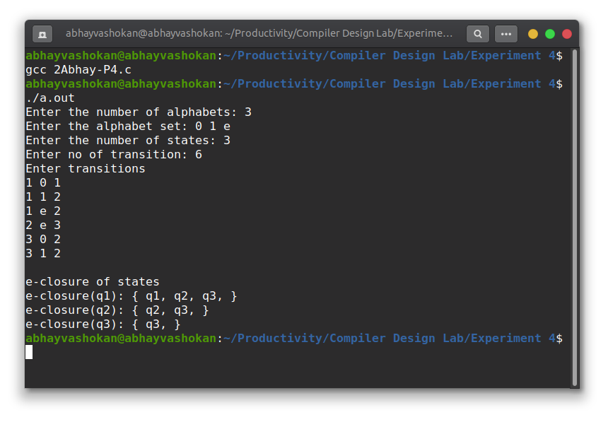

Readme

1. Compile and run the C program using the command

**gcc 2Abhay-P4.c && ./a.out**

2. Enter the number of alphabets

3. Enter the alphabet set

4. Enter the number of states

5. Enter the number of transitions

6. Enter the transitions

7. The ε - closure of all states shall be obtained as output.

**Result**: Successfully implemented a program to find the ε - closure of all the states in an NFA with ε transitions.